**ACCLERATION SENSOR**

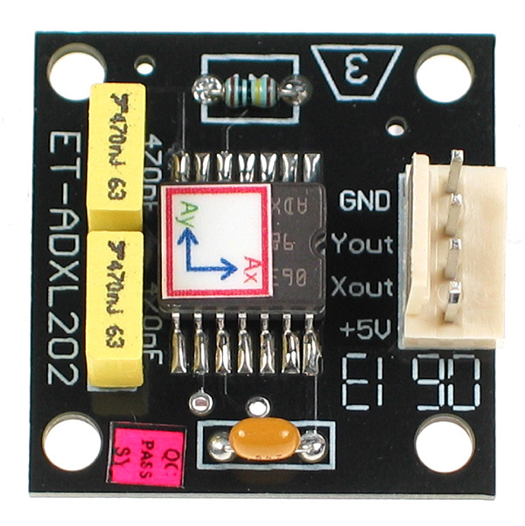

**FEATURES:**

* 2-Axis Acceleration Sensor on a Single IC Chip Measures Static Acceleration as Well as Dynamic Acceleration
* Duty Cycle Output with User Adjustable Period Low Power <0.6 Ma
* Faster Response than Electrolytic, Mercury or Thermal Tilt Sensors
* Bandwidth Adjustment with a Single Capacitor per Axis 5 mg Resolution at 60 Hz Bandwidth +3 V to +5.25 V Single Supply Operation 1000 g Shock Survival

**APPLICATIONS:**

* 2-Axis Tilt Sensing
* Computer Peripherals
* Inertial Navigation
* Seismic Monitoring
* Vehicle Security Systems
* Battery Powered Motion Sensing

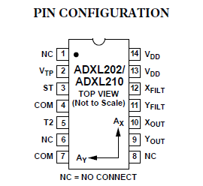

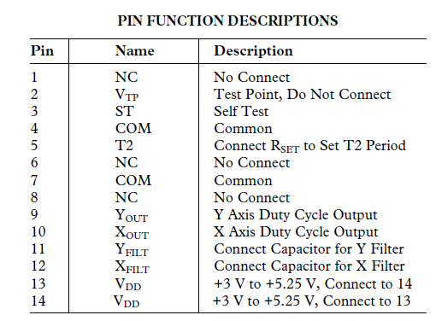

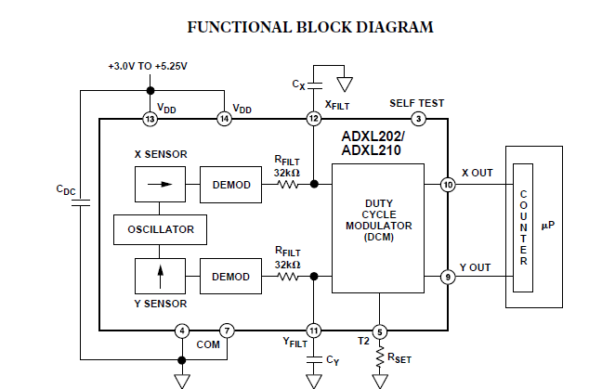

**ADXL202/ADXL210:**

**DEFINITIONS:**

T1 Length of the “on” portion of the cycle. T2 Length of the total cycle. Duty Cycle Ratio of the “on” time (T1) of the cycle to the total cycle (T2). Defined as T1/T2 for the ADXL202/ ADXL210. Pulse width Time period of the “on” pulse. Defined as T1 for the ADXL202/ADXL210.

**THEORY OF OPERATION:**

The ADXL202/ADXL210 is complete dual axis acceleration measurement systems on a single monolithic IC. They contain a polysilicon surface-micro machined sensor and signal conditioning circuitry to implement open loop acceleration measurement architecture. For each axis, an output circuit converts the analog signal to a duty cycle modulated (DCM) digital signal that can be decoded with a counter/timer port on a microprocessor. The ADXL202/ADXL210 are capable of measuring both positive and negative accelerations to a maximum level of ±2 *g* or ±10 *g*. The accelerometer measures static acceleration forces such as gravity, allowing it to be used as a tilt sensor. The sensor is a surface micro machined polysilicon structure built on top of the silicon wafer. Polysilicon springs suspend the structure over the surface of the wafer and provide a resistance against acceleration forces. Deflection of the structure is measured using a differential capacitor that consists of independent fixed plates and central plates attached to the moving mass. The fixed plates are driven by 180° out of phase square waves. Acceleration will deflect the beam and unbalance the differential capacitor, resulting in an output square wave whose amplitude is proportional to acceleration. Phase sensitive demodulation techniques are then used to rectify the signal and determine the direction of the acceleration.

The output of the demodulator drives a duty cycle modulator (DCM) stage through a 32 kW resistor. At this point a pin is available on each channel to allow the user to set the signal bandwidth of the device by adding a capacitor. This filtering improves measurement resolution and helps prevent aliasing. After being low-pass filtered, the analog signal is converted to a duty cycle modulated signal by the DCM stage. A single resistor sets the period for a complete cycle (T2), which can be set between 0.5 ms and 10 ms (see Figure 12). A 0 *g* acceleration produces a nominally 50% duty cycle. The acceleration signal can be determined by measuring the length of the T1 and T2 pulses with a counter/timer or with a polling loop using a low cost microcontroller. An analog output voltage can be obtained either by buffering the signal from the XFILT and YFILT pin, or by passing the duty cycle signal through an RC filter to reconstruct the dc value. The ADXL202/ADXL210 will operate with supply voltages as low as 3.0 V or as high as 5.25 V.

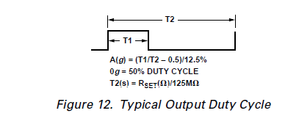

**APPLICATIONS**

**POWER SUPPLY DECOUPLING:**

For most applications a single 0.1 mF capacitor, CDC, will adequately decouple the accelerometer from signal and noise on the power supply. However, in some cases, especially where digital devices such as microcontrollers share the same power supply, digital noise on the supply may cause interference on the ADXL202/ADXL210 output. This is often observed as a slowly undulating fluctuation of voltage at XFILT and YFILT. If additional decoupling is needed, a 100 W (or smaller) resistor or ferrite beads, may be inserted in the ADXL202/ADXL210’s supply line.

**DESIGN PROCEDURE FOR THE ADXL202/ADXL210:**

The design procedure for using the ADXL202/ADXL210 with a duty cycle output involves selecting a duty cycle period and a filter capacitor. A proper design will take into account the application requirements for bandwidth, signal resolution and acquisition time, as discussed in the following sections. **VDD** The ADXL202/ADXL210 have two power supply (VDD) Pins: 13 and 14. These two pins should be connected directly together.

**COM**

The ADXL202/ADXL210 has two commons, Pins 4 and 7. These two pins should be connected directly together and Pin 7 grounded.

**VTP**

This pin is to be left open; make no connections of any kind to his pin.

**Decoupling Capacitor CDC**

A 0.1 mF capacitor is recommended from VDD to COM for Power supply decoupling.

**ST .**The ST pin controls the self-test feature. When this pin is set to VDD, an electrostatic force is exerted on the beam of the accelerometer. The resulting movement of the beam allows the user to test if the accelerometer is functional. The typical change in output will be 10% at the duty cycle outputs (corresponding to 800 m*g*). This pin may be left open circuit or connected to common in normal use.

**Duty Cycle Decoding:**

The ADXL202/ADXL210’s digital output is a duty cycle modulator. Acceleration is proportional to the ratio T1/T2. The nominal output of the ADXL202 is: 0 *g* = 50% *Duty Cycle* Scale factor is 12.5% Duty Cycle Change per *g* The nominal output of the ADXL210 is: 0 *g* = 50% *Duty Cycle* Scale factor is 4% Duty Cycle Change per *g* These nominal values are affected by the initial tolerance of the device including zero *g* offset error and sensitivity error. T2 does not have to be measured for every measurement cycle. It need only be updated to account for changes due to temperature, (a relatively slow process). Since the T2 time period is shared by both X and Y channels, it is necessary only to measure it on one channel of the ADXL202/ADXL210. Decoding algorithms for various microcontrollers have been developed. Consult the appropriate Application Note.

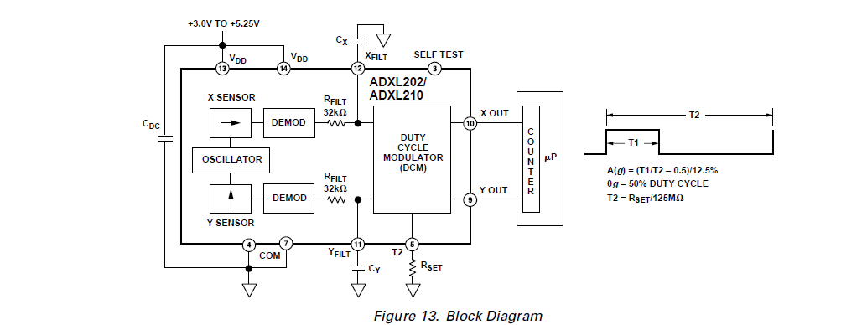

**Setting the Bandwidth Using CX and CY**

The ADXL202/ADXL210 has provisions for band limiting the XFILT and YFILT pins. Capacitors must be added at these pins to implement low-pass filtering for ant aliasing and noise reduction. The equation for the 3 dB bandwidth is: *F*–3 *dB* = 1 (2 p (32 *k*W) ´ *C*(*x*, *y*)) or, more simply, *F*–3 *dB* = 5 m*F* *C*(*X*,*Y* )

The tolerance of the internal resistor (RFILT), can vary as much as ±25% of its nominal value of 32 kW; so the bandwidth will vary accordingly. A minimum capacitance of 1000 pF for C(X, Y) is required in all cases.

**Filter Capacitor Selection, CX and CY Capacitor Bandwidth Value:**

10 Hz 0.47 mF

50 Hz 0.10 mF

100 Hz 0.05 mF

200 Hz 0.027 mF

500 Hz 0.01 mF

5 kHz 0.001 mF

**Setting the DCM Period with RSET:**

The period of the DCM output is set for both channels by a single resistor from RSET to ground. The equation for the period is:

*T*2 = *RSET* (W)

125 *M*W

A 125 kW resistor will set the duty cycle repetition rate to approximately 1 kHz, or 1 ms. The device is designed to operate at duty cycle periods between 0.5 ms and 10 ms. Note that the RSET should always be included, even if only an analog output is desired. Use an RSET value between 500 kW and 2 MW when taking the output from XFILT or YFILT. The RSET resistor should be place close to the T2 Pin to minimize parasitic capacitance at this node.

**Selecting the Right Accelerometer:**

For most tilt sensing applications the ADXL202 is the most appropriate accelerometer. Its higher sensitivity (12.5%/*g* allows the user to use a lower speed counter for PWM decoding while maintaining high resolution. The ADXL210 should be used in applications where accelerations of greater than ±2 *g* are expected.

**MICROCOMPUTER INTERFACES:**

The ADXL202/ADXL210 was specifically designed to work with low cost microcontrollers. Specific code sets, reference designs, and application notes are available from the factory. This section will outline a general design procedure and discuss the various trade-offs that need to be considered. The designer should have some idea of the required performance

Of the system in terms of:

* *Resolution*: the smallest signal change that needs to be detected.
* *Bandwidth*: the highest frequency that needs to be detected.
* *Acquisition Time*: the time that will be available to acquire the signal on each axis. These requirements will help to determine the accelerometer bandwidth, the speed of the microcontroller clock and the length of the T2 period. When selecting a microcontroller it is helpful to have a counter timer port available. The microcontroller should have provisions for software calibration. While the ADXL202/ADXL210 is highly accurate accelerometers, they have a wide tolerance for